Lesson 3
Analysis of oxygen-containing functional groups
Substances containing oxygen functional groups include alcohols, aldehydes, phenols, ethers, carboxylic acids, nitro compounds, amino acids, etc.
1.Ethers-(R-COOR)
Esters with hydroxylamine in an alkaline medium form hydrocamic acid.
Method - to 0.5 ml of 1 n. hydroxylamine hydrochloride solution add 30 ml of methanol. Add a sample and basify with 2 N. alcohol solution of KOH. Heat up to a boil. Add 1 drop of a 10% iron chloride solution, the formation of a red-violet color indicates the presence of an ether.
The hydroxam test is a common test reaction for determining the authenticity of medicinal substances containing ester, lactone, lactam groups in their molecule. As a result of the reaction, hydroxamic acids are formed.
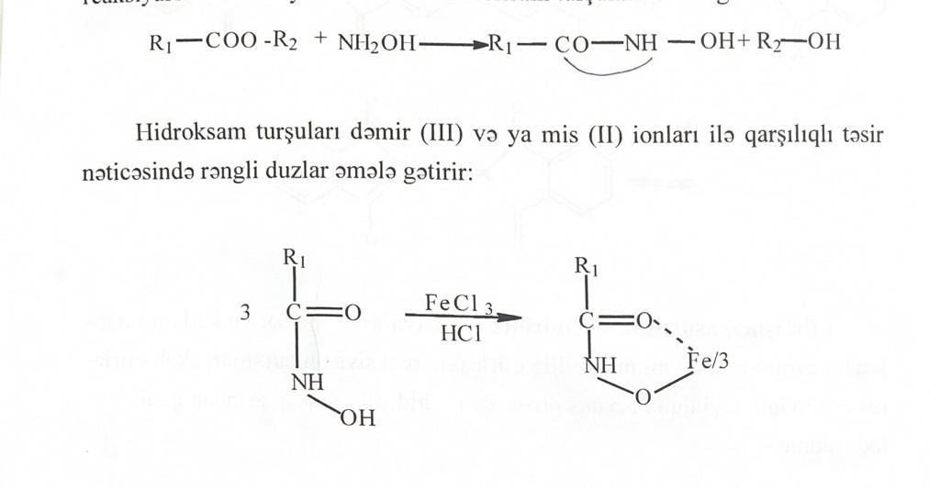
Which with iron(III) or copper(II) ions form colored salts (hydroxamates)
This reaction is given by esters, para-aminophenol derivatives (paracetamol), gluconates (Ca-gluconate), para-aminobenzoic acid derivatives (benzocaine, novocaine), catecholamines (adrenaline), para-aminosalicylic acid derivatives (bepask).
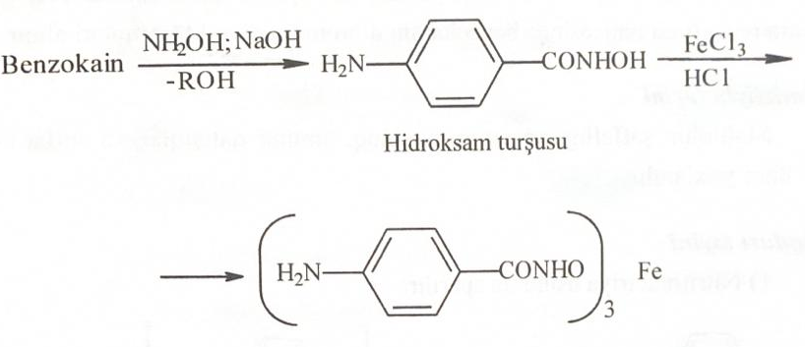
Iron hydroxamate (red)
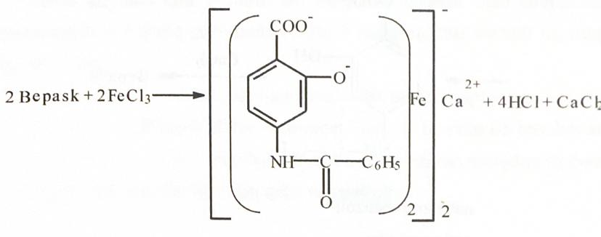
Adrenaline with iron (III) chloride forms an emerald green compound.
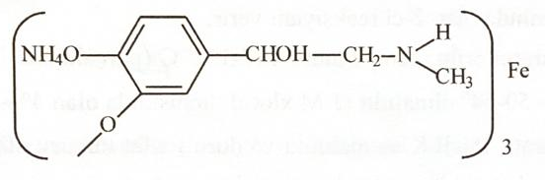
Ca-gluconate
When 2 drops of iron(III) chloride solution are added to the preparation, it forms a light green compound (huconate ion).
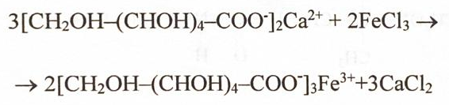
Ascorbic acid, which contains lactone in its molecule, also reacts with iron(III) chloride and is oxidized to diketoascorbic acid by adding 2 drops of FeCl3. When 1 drop of N-hexacyanoferrate is added, a blue color (turnbull blue) is formed.
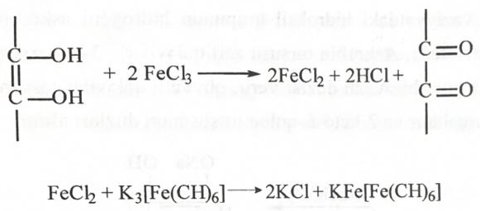
II. Carboxylic acids (R-COOH)
- When sodium bicarbonate solution is added to a solid, carbon dioxide is released.
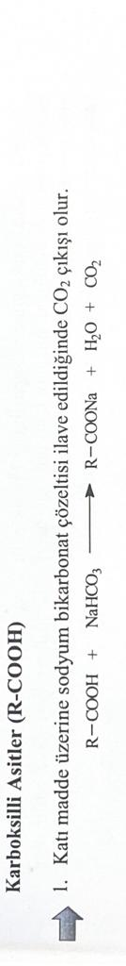
2. Carboxyl compounds, insoluble in water, dissolve in solutions of NaOH and Na-carbonate, forming salts.
Aspirin, a derivative of phenolic acids.
3) Sulfuric acid solution is added to the preparation after alkaline hydrolysis and filtered. Ethyl alcohol and concentrated sulfuric acid are added to the filtrate. There is an odor of ethyl acetate. A solution of iron(III) chloride is added to the precipitate of salicylic acid to form a violet compound.
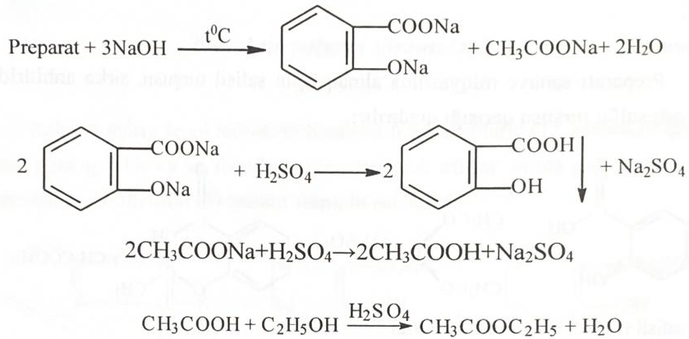
Derivatives of dimethylphenylacetamide Lidocaine.
A solution of sodium hydroxide is added to the preparation, then a solution of cobalt nitrate, the formation of a blue-green precipitate is observed.
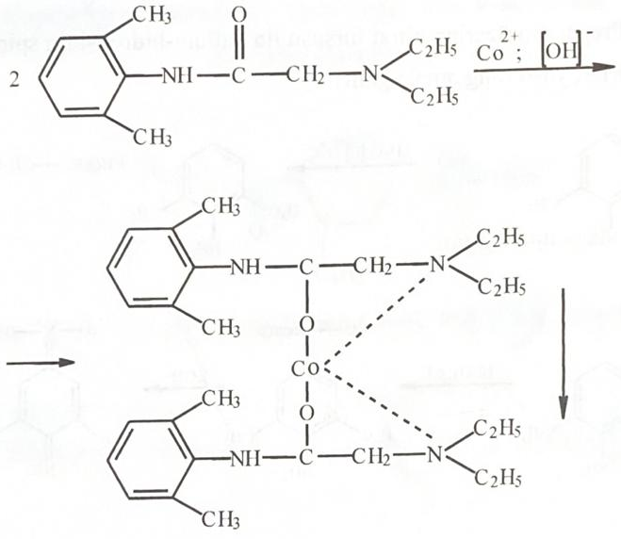
- The iron hydroxamate effect is used for the determination of carboxylic acids, acid chlorides, anhydrides and acid esters.
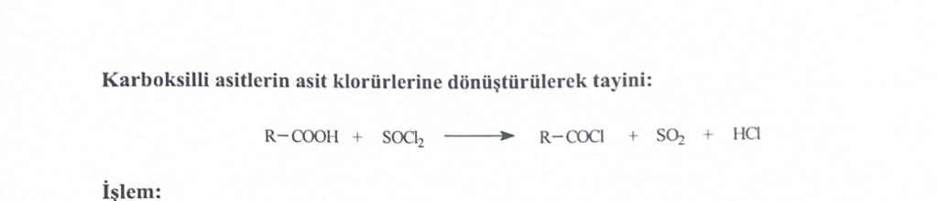
Method - a sample of 100 mg is boiled with 3 drops of thionyl chloride in a dry test tube, after cooling, a test with iron hydroxamate is carried out to determine the acid halides.
Determination of carboxylic acids by conversion to esters
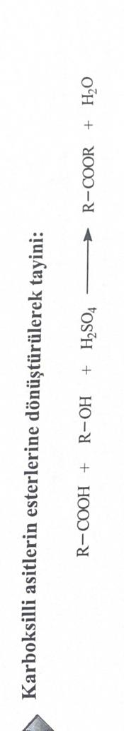
Method - 30-40 mg of the sample is dissolved in 1 ml of alcohol. After adding 1 drop of concentrated sulfuric acid, heat for 5 minutes. After cooling, an iron hydroxamate test is carried out.
Acetylcysteine
The drug is boiled with potassium dichromate and sulfuric acid, then ethanol is added, the smell of ethyl acetate is felt.
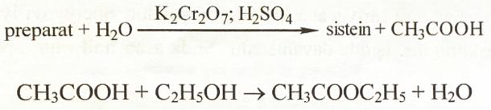
Sulfonamide derivatives (sulfacyl-Na)
The drug with acetic acid forms a white precipitate - sulfacetamide.
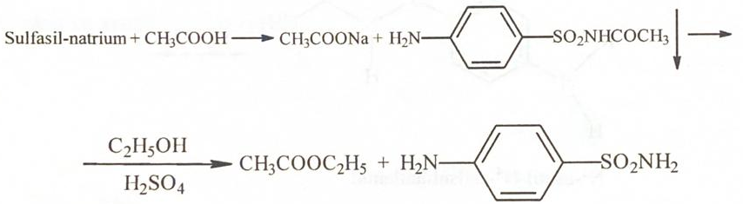
III. Esters (R-O-R)
Ethers are compounds that do not involve chemical reactions. To tell if a sample is an ether or a hydrocarbon, a little iodine is added to the sample.
Esters formation - when ether is heated with sulfuric and acetic acids, it forms an acetic acid ester.
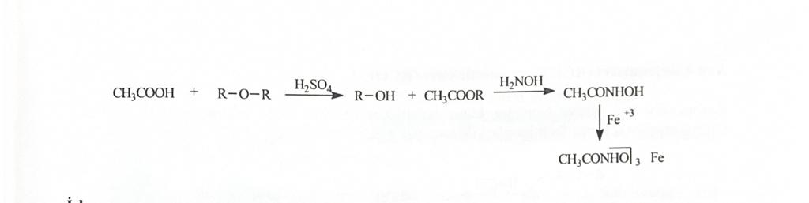
Progress - 100 mg of sample is mixed with 2 ml of glacial acetic acid and 0.5 ml of concentrated sulfuric acid. It is heated for 5 minutes in a circulating refrigerator and the iron hydroxamate test is applied. Alkyl ethers are usually soluble in concentrated hydrochloric acid, while arylaliphatic esters are insoluble.
Derivatives of carbonic acids (salts of Na, K, calcium, etc.). identified by complex formation reactions of anions of organic acids (acetate, salicylate, tartrate, citrate, benzoate, gluconate ions, etc.).
Acetates.
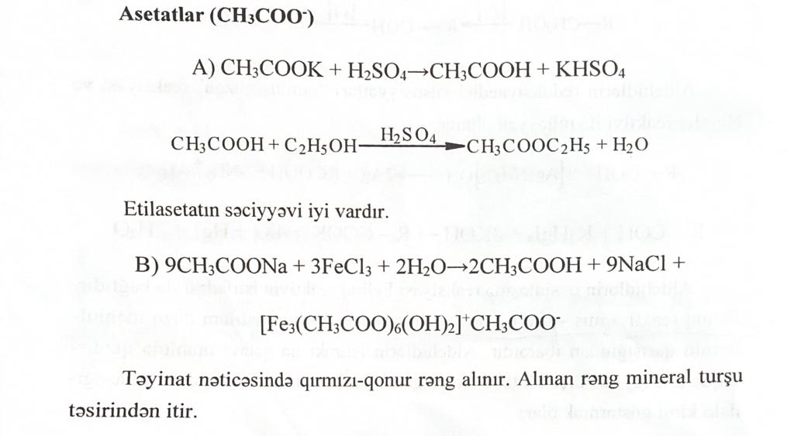
There is a smell of ethyl acetate
A reddish-brown color is observed.
Tartrates.
A) Reaction with potassium ion.
C) Reaction with concentrated sulfuric acid and resorcinol. A reddish-purple color is observed.
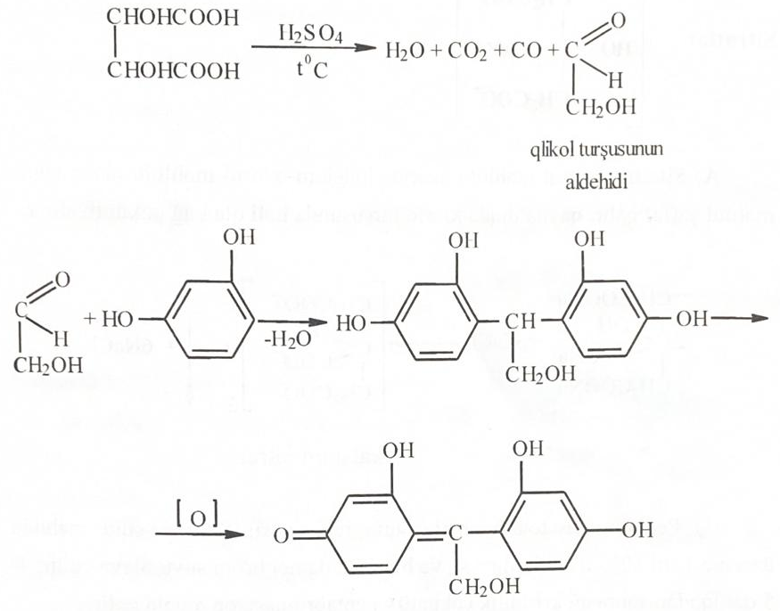
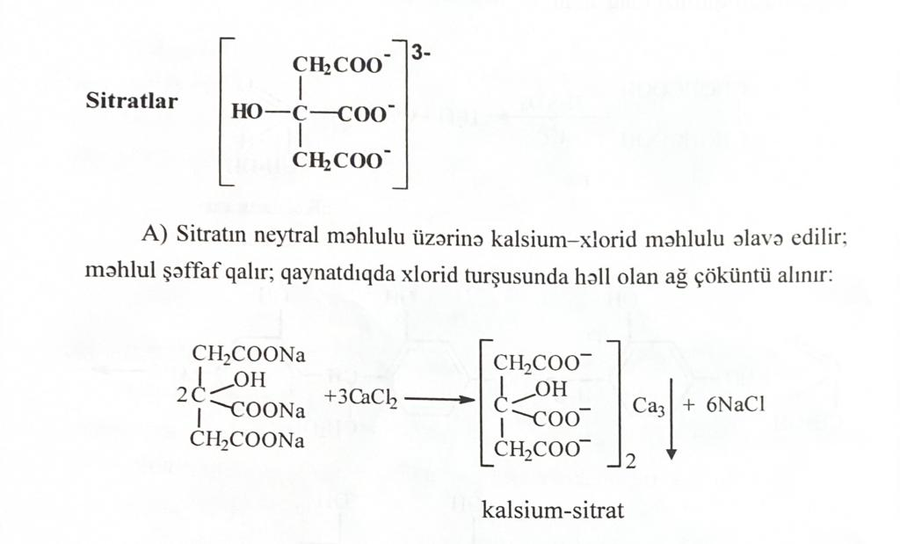
Citrates.
Citrate with calcium ion form a white precipitate of calcium citrate.
Benzoates.
With a solution of iron(III) chloride, a pink-yellow precipitate is formed.
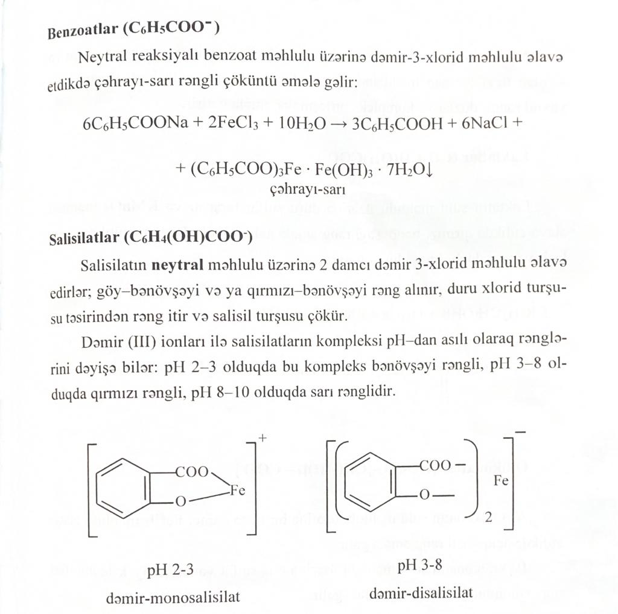
Salicylates.
In a neutral medium with 2 drops of iron(III) chloride, a blue-violet or red-violet compound is formed. At pH = 2-3 iron monosalicylate is formed, at pH = 3-8 iron disalicylate is formed.

Lactates
When dilute sulfuric acid and potassium permanganate are added to lactates, a red-violet color is observed.
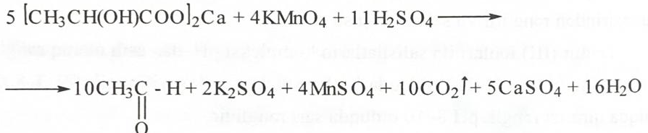
IV. Alcohols (R-OH)
When identifying alcohols, first of all, the presence of alcohol hydroxyl in the structure is examined.
1. Xanthan test --- alcohols form xanthanic acids with carbon disulfide in an alkaline environment, which has a characteristic color. Xanthanic acid can be recognized by its reaction with copper and nickel molybdates to form complex salts.
1) To 5 ml of sediment add 5 drops of 1% copper sulphate. A brown precipitate is formed which quickly turns yellow.
2) One drop of 1% ammonium molybdate is added to the solution and shaken for 5 minutes. Acidified with 2N sulfuric acid, washed with chloroform. A blue-violet color should appear in the chloroform layer.
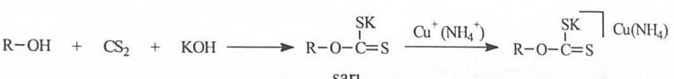
Method - 100 mg of the sample is dissolved in water, 0.5 ml of carbon disulfide and 200-300 mg of KOH are added, shaken for 5 minutes, the formation of a yellow precipitate indicates the reaction.
2. Formation of esters. Alcohols form esters with acetyl chloride. The presence of alcohol is determined by performing a ferrin hydroxamate ester test.
Method - 0.1 ml of acetyl chloride is mixed with 0.1 ml of dimethianiline. Add 0.2 ml of the substance. 5 minutes. shake, add 1 ml of ice water to dissolve the unreacted acetyl chloride, a mixed layer is formed, the upper layer is poured into another container and a ferrihydroxamate test for esters is carried out.
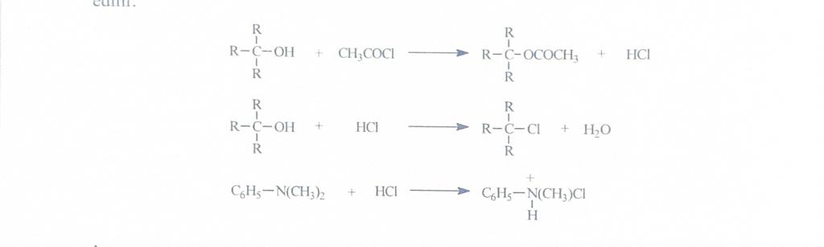
3. Benzoylation (Schotten-Baumann reaction) of alcohols with aromatic acids to form esters that are hardly soluble in water. When alcohols are acidified with benzoyl chloride in an alkaline medium, esters that are sparingly soluble in water are released and the smell of benzoyl chloride disappears (primary phenols and secondary amines also give this reaction).
Progress - 0.1 ml benzoyl chloride, 0.2 ml sample and 20% NaOH are shaken in a closed container for 5 minutes. The disappearance of the smell of benzoyl chloride indicates the end of the reaction.
4. Lucas test - consists of anhydrous ZnCl₂ and HCl.
3-4 drops of the substance are added to 2 ml of the Lucas reagent and shaken vigorously, the mixture is kept at room temperature, the solution becomes cloudy due to the formation of water-insoluble alkyl chlorides.
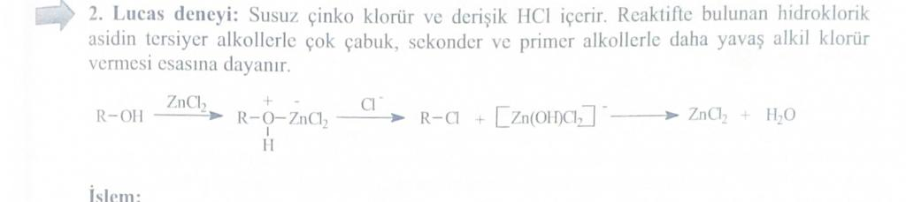

5. Experience of Bordwell-Wellman - the reagent contains chromium oxide and concentrated sulfuric acid.
Oxidizes primary and secondary alcohols, while the orange color of chromium oxide changes to the blue-green color of chromium sulfate.
Progress of work - 15-30 mg of the substance is dissolved in water, 1 drop of the reagent is added to it, washed. Within 10 seconds, primary and secondary alcohols give a blue-green suspension. Tertiary alcohols do not react.
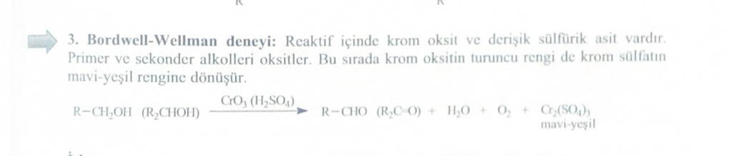
6. When mixing 0.5 ml of ethyl alcohol with 5 ml of NaOH solution and adding 2 ml of 0.05 M iodine solution, a yellow precipitate of iodoform precipitates.
7. Polyhydric alcohols (glycerol) give a dark blue complex with Cu(OH)2 in an alkaline medium.
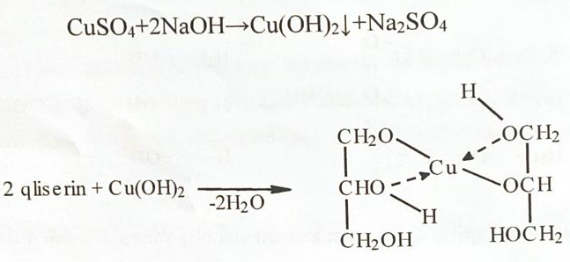
IV Phenols (Ar-OH)
First, the reaction of the sample with iron (III) chloride is checked, if no color is observed, then the following reactions are carried out.
1) Diazonium salts give azo dyes with phenols. The connection may optionally be in the ortho or para position.
The course of work - in three separate test tubes (100 mg of para-nitroaniline and 5 ml of concentrated hydrochloric acid), (2 ml of 10% Na-nitrite solution), (sample solution in 2 ml of 5% NaOH) solutions are prepared and cooled on ice. The diazonium salt obtained by adding the amine solution to sodium nitrite is added to the sample solution. Receiving a red-orange color indicates the end of the reaction.
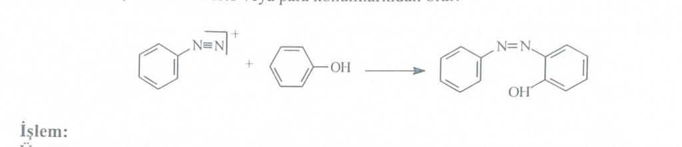
2) Indicator formation
Some phenols form indicator-type substances with phthalic anhydride, substituted phenols do not give such a reaction.
Progress - 2 g of anhydrous ZnCl2 are dehydrated by heating. 300 mg of phthalic anhydride and 50-60 mg of sample are added to it. The molten mass is crushed, the mixture is made alkaline with 2% NaOH. In the presence of phenol, a red color appears.
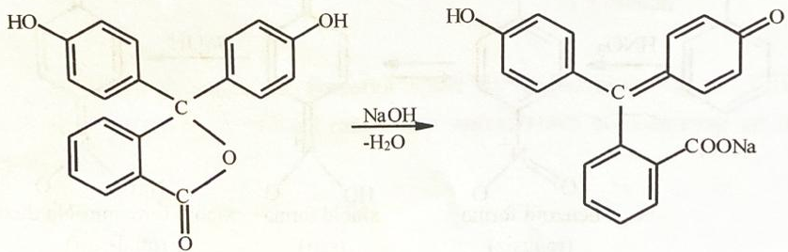
Phenolphthalein Quinoid (red)

3. Lieberman's reaction --- this reaction is given by phenols with nitroso derivatives. Nitrophenols and p-substituted phenols do not give positive results.
Progress of work: 50 mg of the substance is added to 1 ml of concentrated sulfuric acid and 20 mg of Na-nitrite and heated. The appearance of a green, blue or pink color is a positive reaction.
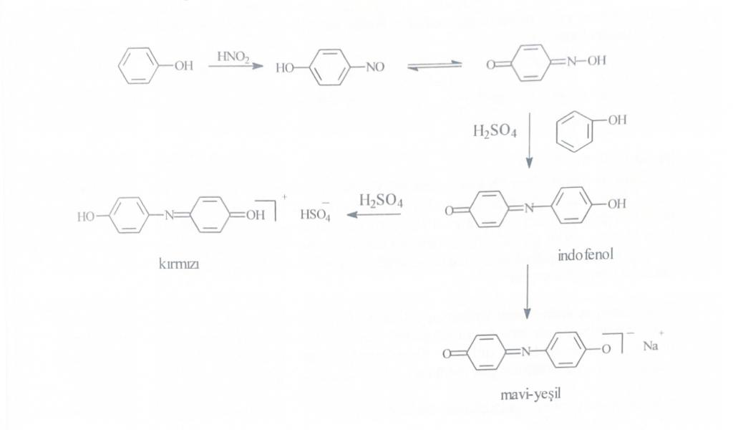 indophenol
bluish blue
- Phenols with dilute nitric acid give yellow ortho- and para-nitrophenols.
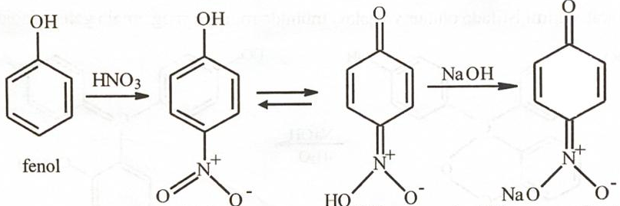
Benzoid Quinoid
- Reaction of aurine dye (red).
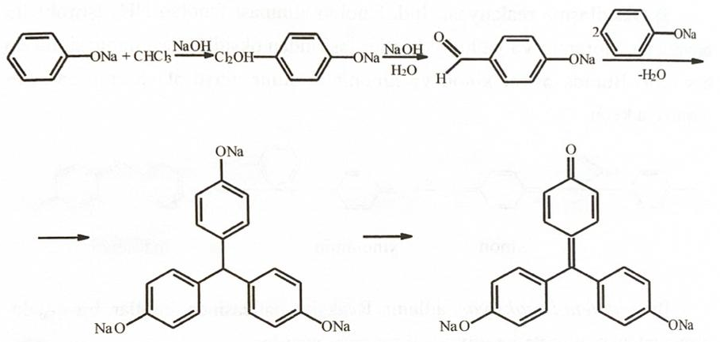
- Condensation reactions include the reaction of phenol with aldehydes (formaldehyde) in the presence of sulfuric acid (Markie's reagent), and a dark cherry color is formed.
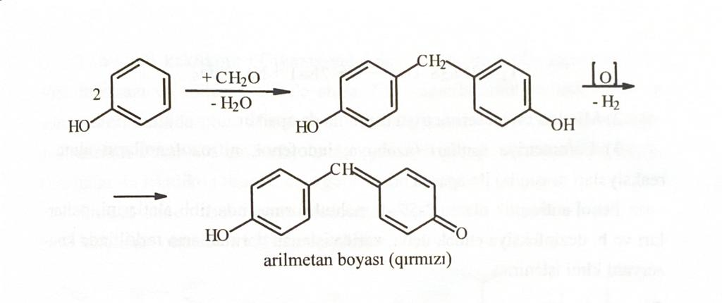
Let's carry out these reactions on the example of resorcinol.
- Reaction with iron chloride.
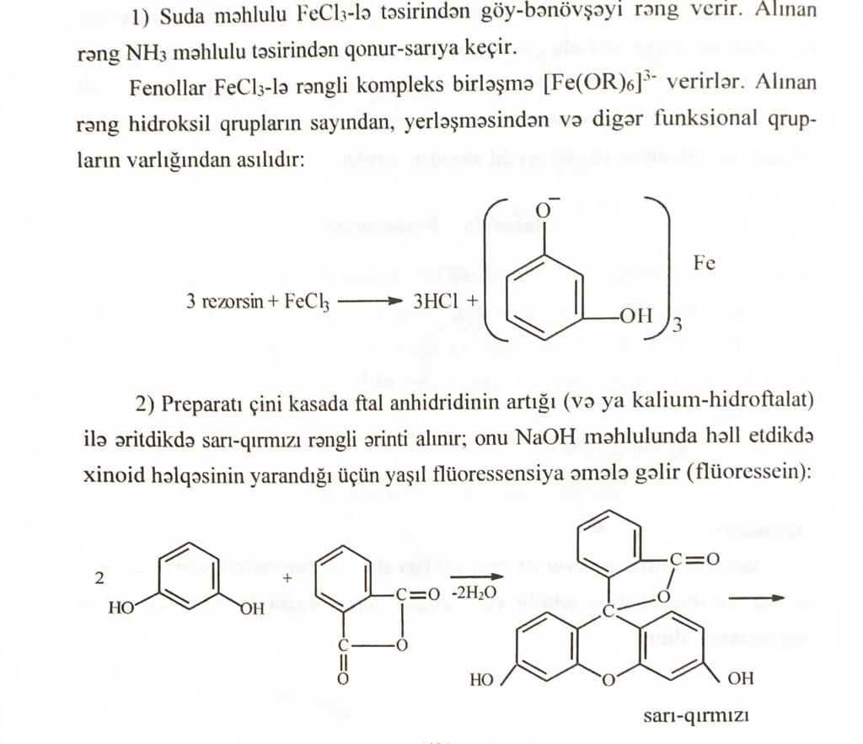
- Fluorescein formation reaction.
yellow red
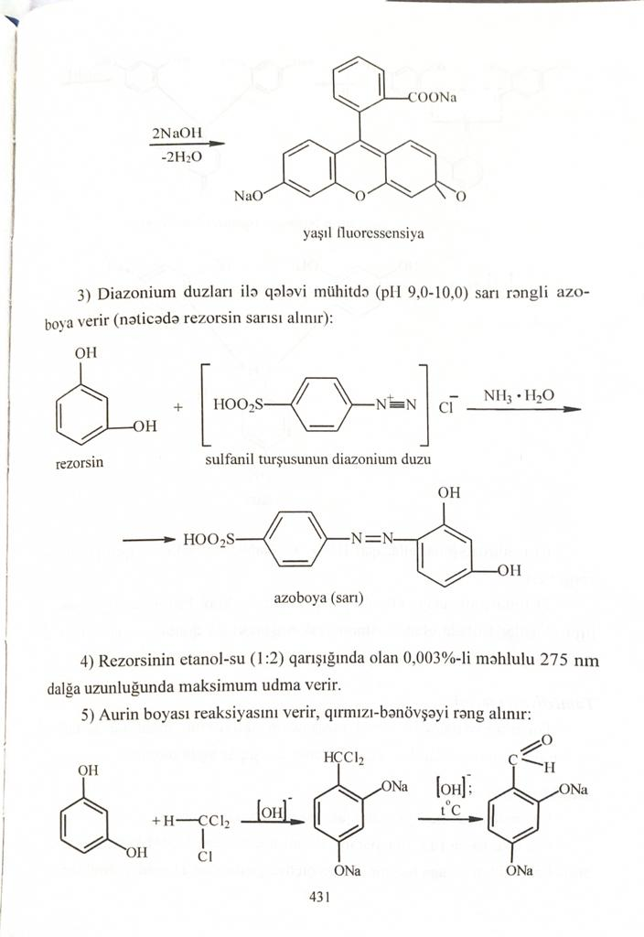
green fluorescence
- The reaction of the formation of an azo derivative.
Azo derivative (yellow)
- The reaction of the formation of aurine dye.
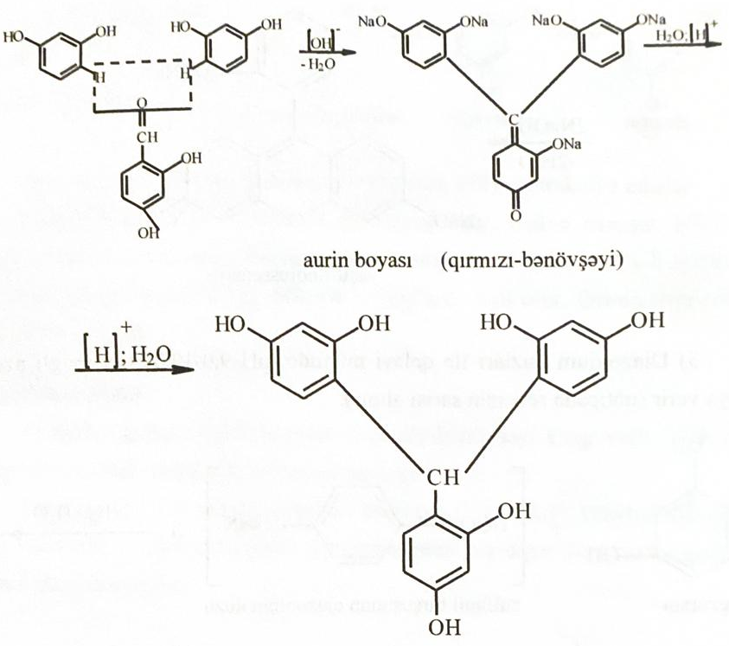
yellow
V. Ketones (R-CO-R)
1. To a saturated 5 ml solution of 2,4-dinitrophenylhydrazine in 2 N hydrochloric acid, add a mixture of 30-40 mg of the substance in 0.5 ml of methanol. Shake vigorously. If there is no precipitate, heat to boiling, if a yellow or orange precipitate has formed, then the reaction has passed.
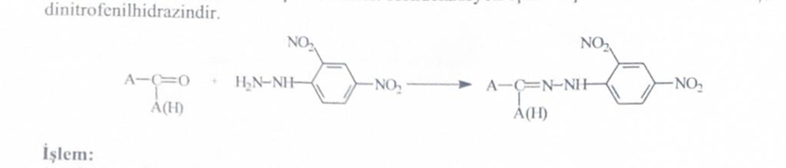
When a carbonyl is detected, the following tests must be performed to determine whether the substance is an aldehyde or a ketone.
The chemical activity of ketones is lower than that of aldehydes, they do not have the property of reduction.
To determine aldehydes, 3 reactions are carried out
a) Color reactions
b) Recovery reactions
c) Condensation reactions (using para-nitrophenylhydrazine).

a) Color reactions
Sheiff's test - for aldehydes and α-hydroxy ketones. To 2 ml of Sheiff's reagent add 3 drops of aldehyde, incubate for 10 minutes at room temperature. If a red color is received inside, the reaction is received.
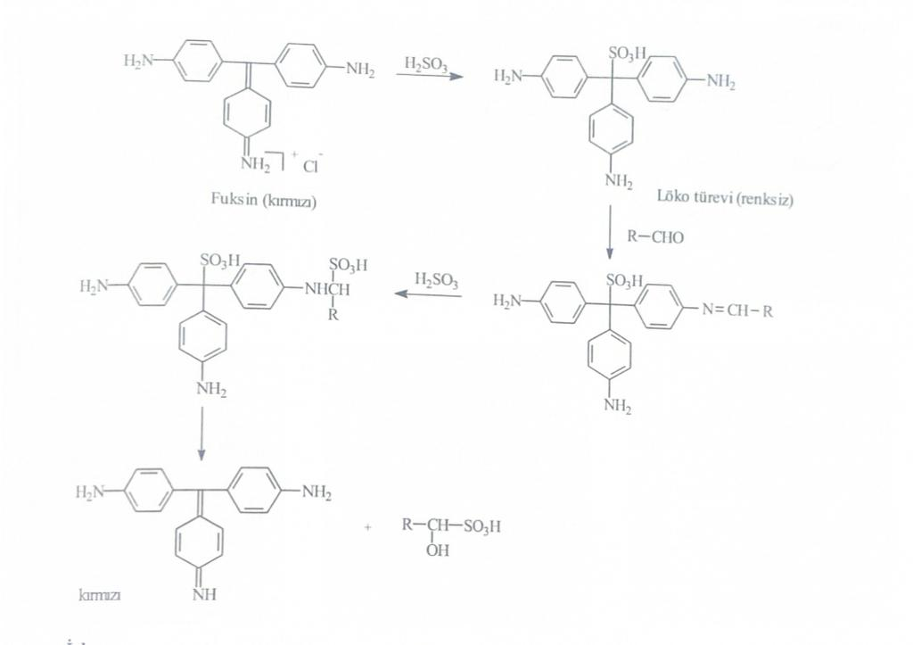
b) Condensation reactions
1. Medon's test. Aldehydes condense with Medon's reagent (5,5-dimethyl-1,3-cyclohexadione), 1 mol of aldehyde forms dimedone with 2 mols of the reagent.
Progress. 50 ml of the substance and 3 drops of a 5% solution of medon in alcohol are added to 1 ml of water and shaken for 2 minutes. If the process produces a milky slurry, there is an aldehyde present. If a precipitate forms within 5 minutes, this indicates the production of octahydroxanthene.
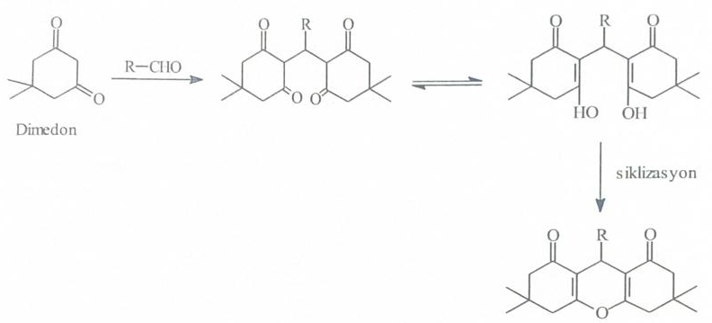
2. 2-hydrazinothiazole test-
It is used in the determination of aliphatic aldehydes; ketones do not give in this reaction.
Progress of work: add 1 drop of 2-hydrazinothiazole reagent and an aqueous solution of the substance and mix for 2 minutes. After waiting, add 1 drop of iron cyanide, shake for 2 minutes. Then add 1 drop of 10% KOH. The formation of a dark blue color within 5 minutes indicates a positive reaction. For large molecular weight aldehydes, wait 30 minutes.
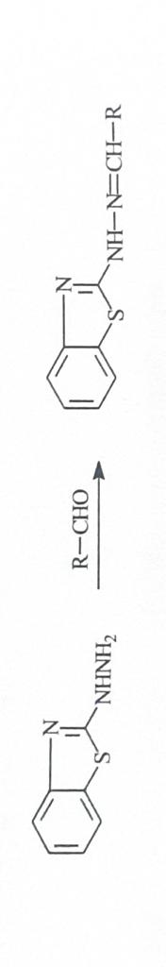
c) Recovery reactions
1) Tollen test --- (ammonium hydroxide) gives this reaction especially with aldehyde carbonyl. Ketones having in their structure a hydroxyl group adjacent to a carbonyl, easily oxidized sugars, polyhydroxyphenols and other reducing agents also give this reaction. The newly prepared reagent contains a diamino silver complex, this complex with aldehyde is reduced, and in doing so releases silver.
Progress. 30-50 mg of the substance is added to 2 ml of freshly prepared Tollen's reagent, washed and left for 10 minutes. If during this time metallic silver is not formed, it is placed in a water bath for 5 minutes. Silver is formed on the wall of the test tube.
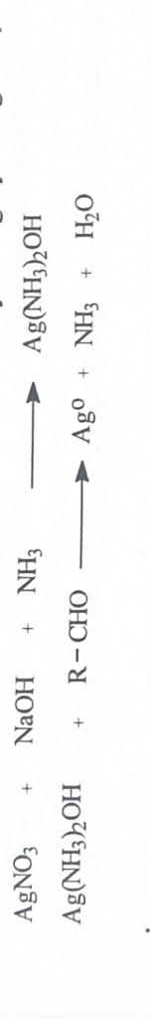
2) The Fehling test is based on the reducing power of aldehydes.
Progress of work - To a solution of 500 g of a substance in a solvent without a carbonyl group, add the same volume of Fehling's solutions A and B and heat. The formation of a red precipitate consisting of Cu2O indicates that the reaction is positive.
Fehling's reagent is a mixture of solutions of copper sulphate and potassium-sodium salt of tartaric acid.
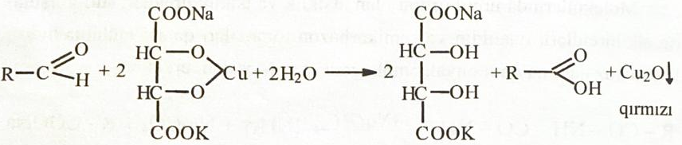
3) Benedict's reaction. Aliphatic aldehydes and α-hydroxy ketones give a yellow-red precipitate with Benedict's reagent.
Progress of work: Add 2 drops of a sample to 2 ml of Benedict's reagent, add 0.5 ml of water or alcohol and boil, a yellow-red precipitate indicates a positive reaction.
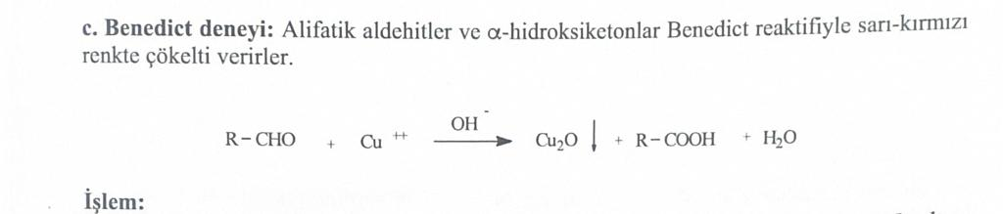
Vanillin is also used to determine aliphatic ketones.
Progress of work: a mixture consisting of 50 mg of the sample, crystalline vanillin, 4 ml of water, 2 ml of concentrated sulfuric acid is stirred, a dark red color is formed. The solution was placed in a water bath for 15 minutes. Turns purplish red when heated.
VI. Nitro compounds (R-NO2)
1. They can be identified by the oxidizing property of the nitro group. Nitro compounds oxidize iron(II) hydroxide to iron(III) hydroxide.
Progress of work: 20 mg of the substance is mixed with 1.5 ml of a freshly prepared 5% solution of iron ammonium sulfate, 1 drop of sulfuric acid and 1 ml of 2 n. alcohol solution of KOH. If after 1 min. the solution turns red-brown, then the reaction is positive.

2. Recovery with hydroxylamine
Progress of work: 500 mg of ammonium chloride and 500 mg of zinc powder are added to a solution of 500 mg of the substance in 10 ml of 50% ethanol, heated to a boil, cooled, filtered and freed from excess zinc. The filtrate is mixed with Tollen's reagent. The appearance of silver indicates that the reaction is positive.
3. Aliphatic nitro compounds are determined when mixed with a NaOH solution with the formation of a yellow color, which loses its color upon acidification.
4. Secondary and tertiary nitro compounds give blue stains with diphenylamine and diphenylbenzidine.
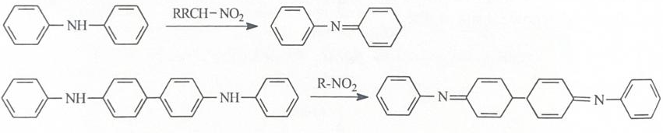
VII. The ninhydrin reaction is a common reaction for aliphatic amino acids and polypeptides. With ammonia released from these compounds, ninhydrin forms a blue-violet condensation product - diketihydrindylidene-diketohydramine ion (Rusman's blue-violet dye).
Identification of glutamic acid
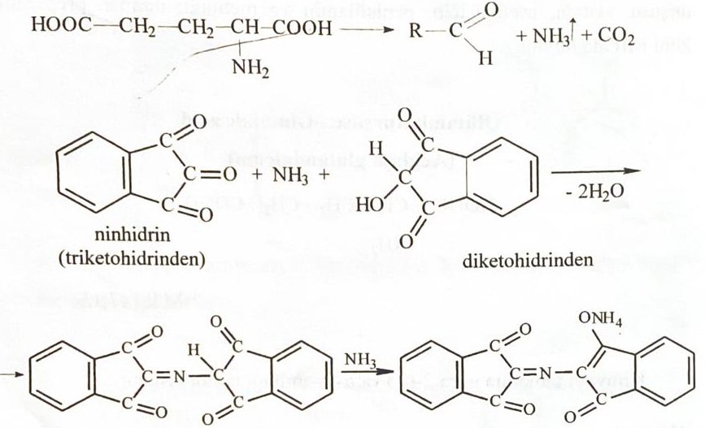
VIII. Aromatic amino acids (salicylic acid) give colored complexes with FeCl3, aurine dye with Mark's red reagent, dark blue compound with copper(II) salts.
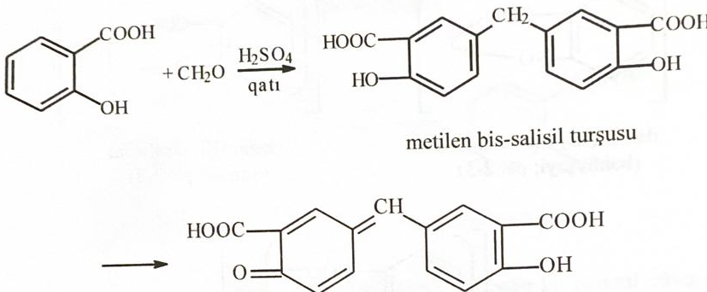
Auric dye
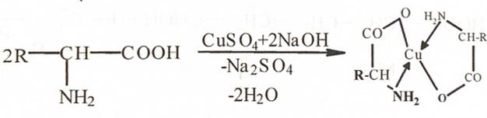
Complex with copper
IX. Natural carbohydrates (glucose) are determined with Fehling's reagent, Tollens' reagent, with phenylhydrazine.
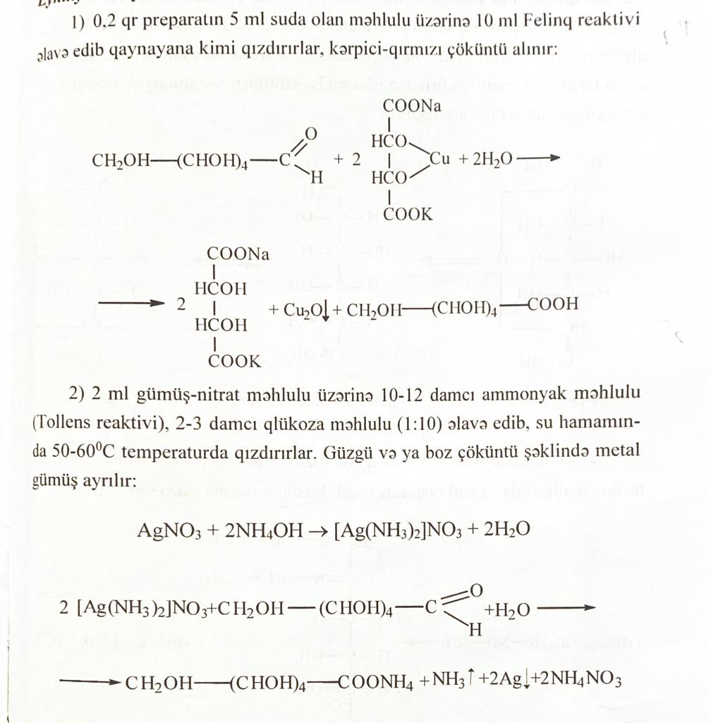
Brick red sediment
Gray precipitate of silver

